Five Spot Competition
(rule version – 20180403)

Objective: The floor of a room is marked in four corners and the approximate room center with circles or portions of circles using blue painter’s tape. All obstacles present in the room along with possible additions are left in place. The challenge is for the robot to start at a location selected by the judges and drive into each of the five marked areas.

Acknowledgement: The initial idea for this contest was gleamed from the Seattle Robotics Society’s Yahoo group. Five Spot is a more formal competition designed to build the obstacle avoidance and navigation skills of the contest participants.

Robot: Competing robots must run autonomously but are not required to be self-contained. Robot size is limited to less than 24x24x48 inches all through the contest run. Maximum robot weight is 30 pounds. Robots must be designed to not damage the floor or the environment of the room. The robot may not split into multiple parts, but it may change shape as long as all parts stay connected and within the 24x24x48 envelope.

Robots Owner: If a robot is a team effort they must designate one person as the one who can make decisions as the robot’s owner.

Self-Contained Definition: Self-contained means that all computing power used to run the robot is carried on the robot platform.

Run Definition: A run starts when the robot is placed at the starting line of the course and is given a signal from the judge. The run ends when either the robot has visited all target areas, runs out of time, malfunctions, or the judges declares the run to have ended. The judges will end the run if a robot either becomes stuck or trapped in a location by obstacles or has stopped moving for greater than 45 seconds. The robot owner is responsible for declaring that a robot has malfunctioned. The time limit per run is 5 minutes. Each robot is allowed 1 run per contest round. Once the robot moves past the starting line, it is considered to have participated in that run.

Round Definition: A round consists of a single run by each competing robot. The competition consists of 3 rounds. If you are not able to start your robot in any round, you forfeit your run in the round. Exchange of starting slots between contestants is allowed. Any runs after the three official rounds will not be scored for the contest.

Play: The five target areas will be marked on the room’s floor about an hour before the competition. Competitors will be allowed to practice during before the competition however, room traffic and obstacle movement will not be controlled. This means that room obstacles at the start of the competition may be different than those experienced during the practice session.
The robot must traverse the course using the floor.

Competitors may use up to 5 beacons however, they may not be placed in or within 1 foot of the target areas. Beacons must be placed on the course before the robot’s run and removed after the run by the robot owner. Maximum beacon size (plus any supports) is 6x12 inches.

The robot owner and all team members must wait at the door or in the spectator area during the robot run.

If a robot moves an obstacle during a run, the obstacle will be returned to its original position for the next robot.

Visited Definition: If any portion of the robot crosses over the blue tape outlining a target zone, it is considered to have visited that target.

Beacon Definition: Any object that is added to the course or surrounding area, other than the robot, that actively or passively provides information to the robot is considered a beacon.
Scoring: A robot’s score is based on it time to complete all tasks and the number of target zones visited. One hundred points are added to the robot’s score for each first time visit of a target area. If the robot successfully visits all target zones, the run ends. The following formula is used to determine the score.

Run Score = (300 – (300 or time to visit all 5 target zones) + 100 * (# of target zones visited)

Scoring examples: A robot that visits two target areas but runs out of time would have a score of
200.
Calculation: (300 – 300 + 2 * 100) = 200
A robot that visits all 5 target areas in 90 seconds would have a score of 710.
Calculation: (300 – 90 + 5 * 100) = 710

The winning robot is determined by comparing the best run scores of each robot. Second and third place are determined in a similar manner.

Course: The course is an indoor room. Four corners of the room will be marked with a 90-degree arc of an 18-inch radius circle. The approximate center of the room will be marked with an 18-inch radius circle. The marks will be made with ¾ inch blue painter’s tape.

An area along one wall of the room will be reserved for spectators and will contain chairs. Spectators may move around in the reserved area but should not leave the area when a robot is making a run.

Any obstacle or room clutter that is present at the start of the contest will be left in place, unless it resides in a target area or totally blocks all paths to a target area. The judges may add or adjust obstacles.

The judges will select a location in the room that will be used as the starting point for every robot run.

The course will not change during the contest.
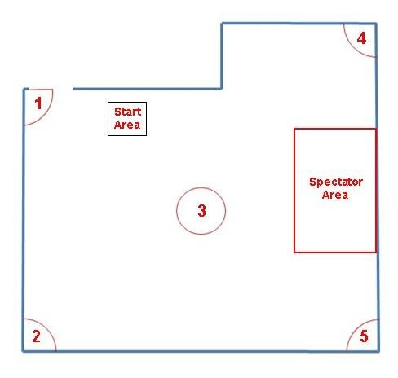
Example five-spot room layout – not to scale

Judging: One or more judges will referee the contest. They will ensure the rules are followed and remove a robot from competition if the robot is operating in an unsafe manner or damaging the environment. The decisions of the judges are final.

